# Hypertension in Marion County, Indiana: 2015

**How is High Blood Pressure (Hypertension, HBP) Diagnosed?**

**Blood pressure screening for adults ages 18 and older**: Blood pressure (BP) readings should be based on the average of two or more properly measured, seated BP readings on each of two or more office visits[1].

1. **Pre-hypertension**: Those with BP readings of 130–139 SBP range or DBP of 80–89 millimeters of mercury (mmHg). These individuals are at twice as likely to develop hypertension as those with lower values[2].
2. **Hypertension (HBP)**: Is defined as[3]:
   1. A systolic (SBP) reading of 140 mmHg or more, or a diastolic (DBP) reading of 90 mmHg or more, or
   2. Current treatment with anti-hypertension medication, or
   3. Having been told at least twice by a health professional that one has HBP
3. **In children and adolescents:** HBP is defined as three sequential clinical readings of a SBP or DBP levels which fall in the 95th percentile of blood pressure readings for the child’s age, gender and height. A single reading of elevated BP in children is not sufficient for a clinical diagnosis of HBP[4].

**Prevalence:**

Hypertension affects approximately 50 million Americans, and is the most common primary diagnosis in the U.S. (35 million office visits per year as the primary diagnosis)[5].

* Nearly one in 3 Americans has been told they have hypertension (BRFSS 2007-2008).[6]
* About 6% of Americans have undiagnosed hypertension (NHANES 2007-2010)[7].
* Some 3-4% of U.S. children ages 8 to 17 have BP readings in the upper 95th percentile for age and gender (2003-2006)[8]. In NHANES national samples of adolescents aged 12-17, prevalence of hypertension did not change significantly between 1999 and 2008 ranging between 3-5%, but did increase with age and increasing levels of obesity[9].

In 2013, an estimated 32% of Marion County adults reported that they had been diagnosed with hypertension which was similar to the national rate of 31.4%[10]. A 32% hypertension prevalence translates to almost 219,000 Marion County adults that have been diagnosed with hypertension[11]. The prevalence of hypertension in Marion County among Behavioral Risk Factor Surveillance System (BRFSS) sample years between 2003 and 2013 did not vary significantly (see confidence intervals in Figure 1). Hypertension is not evenly distributed spatially throughout Marion County (Figure 2). The prevalence of hypertension ranged from 25% to 43.4% among Marion County Public Health Department planning areas in 2012.

Figure : Prevalence of high blood pressure, adults age 18 and older, Marion County, BRFSS 2003-2013

Source: BRFSS Survey Data (DR2647). Note: The BRFSS only collects information reflecting BRFSS prevalence every other year (in odd-numbered years). BRFSS survey methods changed from all land-line phone sampling in 2010 to added cell-phone sample (about 30% of total sample in Indiana) thereafter. CDC recommends that readers not directly compare trends across these periods.

Figure : Marion County Hypertension Prevalence Distribution by Health Planning Area, 2012

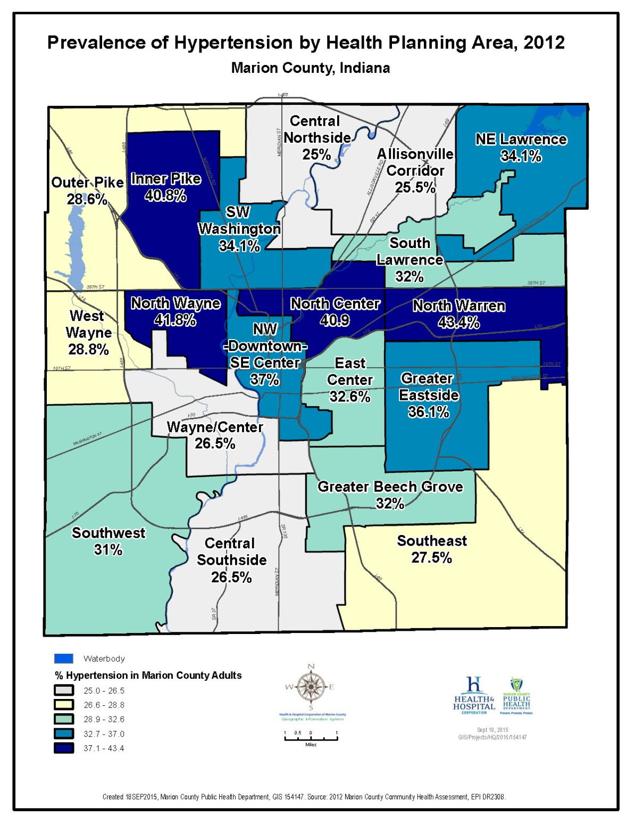

A 2012 telephone survey of over 5,000 Marion County adults provides the most recent detailed information on age-group, race/ethnicity, and gender differences in hypertension prevalence. The prevalence of hypertension in Marion County increases significantly with age (Table 1). Prevalence among Marion County residents ages 65 and over was 6.6 times higher than residents ages 18-34 and 1.8 times higher than residents ages 35-64 (Table 1). The prevalence of high blood pressure was higher than among African Americans in Marion County than among Marion County Whites and Hispanics (Figure 3). No statistically significant differences of hypertension prevalence were seen in male-to-female comparisons (Table 1).

Table : Prevalence of Hypertension by Age Group, Gender, and Race, Marion County, 2012

|  |  |  |  |
| --- | --- | --- | --- |
| **Category** | **Marion County Hypertension Prevalence (95% CI), 2012** | **Indiana Hypertension Prevalence, 2011** | **U.S. Hypertension Prevalence, 2011** |
| Ages: 5-11 | 1.0 % (-0.1 - 2.2) |  |  |
| Ages: 12-17 | 0.9 % (0.0 - 1.8) |  |  |
| Ages: 18-34 | 9.7 % (7.1 - 12.3) |  | 10.3% (9.9-10.7) |
| Ages: 35-64 | 35.0 % (32.6 - 38.1) |  | 33.5% (33.2-33.9) |
| Ages: 65 and over | 64.0 % (59.6 - 67.6) |  | 62.0% (61.6-62.5) |
|  |  |  |  |
| Female | 30.8 % (28.3 – 33.3) | 31.3 % | 30.0 % |
| Male | 31.0 % (31.0 – 34.0) | 34.4 % | 32.1 % |
|  |  |  |  |
| White | 31.2 % (28.8 - 33.6) | 33.3% | 31.7 % |
| Black | 38.5 % (34.3 - 42.7) | 36.6% | 39.2 % |
| Hispanic | 16.0 % (10.8 - 21.2) | 17.7% | 22.4 % |
| **Total** | **31.0 % (28.9 - 32.8)** | **32.8%** | **30.9 %** |

Source: 2012 Marion County Community Health Assessment Survey (DR1983; DR2647), BRFSS Survey Data.

Figure : Prevalence of High Blood Pressure by Race, Marion County, 2012

Source: 2012 Marion County Community Health Assessment Survey (DR2647).

Morbidity:

The national rate of hospitalizations for heart disease in 2010 was 21% higher than the Marion County rate of 99.8 per 10,000 population in 2013 (Table 2). The rate of hospitalizations for essential hypertension was over 2 times higher nationally than it was in Marion County (Table 2).

Table : Marion County and U.S. Hospital Discharges per 10,000 Population

|  |  |  |
| --- | --- | --- |
| **Principal Diagnosis (based on ICD-9)** | **Marion County, 2013** | **U.S., 2010** |
| Heart Disease  (391-392.0, 393-398, 402, 404, 410-416, 420-429) | 99.8 | 121.0 |
| Cerebrovascular Disease  (430-438) | 29.2 | 33.0 |
| Essential Hypertension  (401) | 4.1 | 9.1 |
| Chronic Kidney Disease  (580-589) | 20.0 | NA |

Sources: CDC/NCHS National Hospital Discharge Survey, 2010; Marion County Hospital Discharge data (DR2647). U.S. Census Bureau. Both U.S. and Marion County rates are unadjusted. The hospitalization rate for chronic kidney disease was not available at the national level.

**Mortality:**

The age-adjusted death rate for heart disease in Marion County was 191.5 per 100,000 population in 2013, 13% higher than the national rate of 169.8 per 100,000 (Table 3). The mortality rates for cerebrovascular disease and essential hypertension in Marion County were similar to the national rates (Table 3). The death rate from chronic kidney disease in Marion County was 57% higher at 20.7 deaths per 100,000 population than the national rate rate of 13.2 per 100,000 (Table 3).

Table : Marion County and U.S. Age-Adjusted Death Rates by Cause per 100,000 Population, 2013.

|  |  |  |
| --- | --- | --- |
| **Primary Cause of Death (based on ICD-10)** | **Marion County** | **U.S.** |
| Heart Disease  (I00-I09,I11,I13,I20-I51) | 191.5 | 169.8 |
| Cerebrovascular Disease  (I60-I69) | 37.8 | 36.2 |
| Essential Hypertension  (I10,I12,I15) | 8.6 | 8.5 |
| Chronic Kidney Disease  (N00-N07, N17-N19, N25-N27) | 20.7 | 13.2 |

Sources: Indiana State Department of Health, Epidemiology Resource Center, Data Analysis Team (2013); National Vital Statistics data, NVSS (2013). Both Marion County and U.S. rates per 100,000 population have been age-adjusted.

**High Blood Pressure Risks:**

The relationship between increasing levels of blood pressure and increasing risk of CVD events is a continuous, consistent, and independent risk factor for poor outcomes, regardless of other cardiovascular risk factors[12].

A reduction in as little as 2 mmHg in average population DBP among 35-64 year olds could result in a 17% reduction in hypertension, 14% fewer stroke events, and 6% fewer heart attacks[13].

• In persons older than 50 years, systolic blood pressure greater than 140 mmHg is a much more important cardiovascular disease (CVD) risk factor than diastolic blood pressure[14].

• The higher the BP, the greater the chance of heart attack, heart failure, stroke, and kidney disease (organ endpoints of HBP). Each increment of 20 mmHg in systolic BP (SBP) or 10 mmHg in diastolic BP (DBP) doubles the risk of CVD over the entire BP range from 115-185 SBP and 75-115 DBP mmHg[15].

* Individuals who have normal BP levels at age 55 have a 90 percent lifetime risk for developing hypertension[16].
* Persons with normal cholesterol, and blood pressure and do not smoke have 72%-85% lower mortality rates from cardiovascular disease and 40-58% lower all-cause mortality than do people who have 1-3 of these modifiable risk factors[17]. The lower risk group also enjoyed 6-9.5 additional years of life expectancy.
* In the U.S., hypertension causes 35% of heart attacks, 35% of strokes, 49% of heart failure episodes, and 24% of premature deaths[18].
* The direct and indirect costs of hypertension in the U.S. was over $51 billion (2009) and is projected to rise to over $343 billion 2030[19].

**Management of hypertension:**

In 2000, 70% of Americans ages 18-74 who had HBP were aware of their condition, and 60% were being treated, but only 1 in 3 (34%) were able to keep their BP in the normal range, with medication[20].

Treatment of hypertension or pre-hypertension involves: 1) lifestyle modifications, and in more severe cases, 2) anti-hypertension medication therapy.

Treating BP to targets of under 140/90 mmHg is associated with decreased in CVD complications. Antihypertensive therapy reduces stroke incidence by 35–40%, heart attack (myocardial infarction) risk by 20–25% and heart failure by over 50%[21].

**Risk Factors for Hypertension**

Non-modifiable risk factors for developing high blood pressure include factors that an individual has less control over, but warrant awareness by individuals and their health care providers. These include:

* Increasing age
* Male gender (in those over 40)
* Family history of hypertension
* Minority status
* Low education and low socio-economic status[22]
* Current clinical conditions[23]

Other risk factors might be modifiable, such as sleep apnea and the use of oral contraceptives.

Young people with one or more cardiovascular risk factors, including elevated blood pressure, have been found to have increased risk of end-organ damage such as carotid artery thickening, and left ventricular thickening[24]. The National High Blood Pressure Education Program and the American Academy of Pediatrics has recommended that children over age 3 have their BP measured at any health care visit, as pre-hypertension/hypertension is often under-recognized in children.

**Lifestyle Modifications**

Adoption of healthy lifestyles is critical for the primary prevention of HBP and is an indispensable part of the management of those who have developed hypertension.

Lifestyle modifications shown to lower BP include:

* **Achieve a normal body weight** (a Body Mass Index (BMI) of 18.5-24.9 kg/m2)[25].
* **Adopt the Dietary Approaches to Stop Hypertension (DASH) eating plan**[26], which is

rich in potassium and calcium[27], fruit, vegetables, legumes, nuts, low-fat and low-saturated fat products[28].

* **Reduce Dietary Sodium** to under 2300 mg/day[29] and **maintain a potassium intake** of (> 90 mmol/day)[30].
* Most of our daily sodium (salt) intake (over 75%) comes from processed foods and eating out, while little of our daily salt comes from a salt shaker.
* Americans have an average intake of 3,266 mg of salt per day (2007-2008), well above recommended levels (2,300 mg daily)[31]. Sodium per calorie consumed (sodium density) was highest in fast food and pizza restaurant settings[32].
* Higher potassium intake can help lower BP, including use of bananas, potatoes, yogurt and dried beans.
* **Get regular physical activity** of 30 min/day [33].
* Regular aerobic physical activity (e.g., brisk walking) for at least 30 minutes a day for most days of the week has been recommended for primary prevention of hypertension.
* **Limit alcohol intake** to 1 drink per day for women and 2 drinks per day for men[34].
* **Eliminate tobacco use**[35]. Smoking raises your blood pressure and increases risk of heart attack.

The individual contributions of some of these changes can be viewed in Figure 4 below.

Figure Lifestyle Modifications to Manage High Blood Pressure



JNC 7 Express. The Seventh Report of the Joint National Committee on Prevention,Detection,Evaluation, and Treatment of High Blood Pressure,2003

## Sources

1. JNC 7 Express. The Seventh Report of the Joint National Committee on Prevention,Detection,Evaluation, and Treatment of High Blood Pressure. U.S. Department of Health and Human Services, National Institutes of Health, National Heart, Lung, and Blood Institute, NIH Publication No. 03-5233, December 2003, page 2
2. Vasan RS, Larson MG, Leip EP, et al. Assessment of frequency of progression to hypertension

   in nonhypertensive participants in the Framingham Heart Study:

   A cohort study. *Lancet.* 2001;358:1682-6. F
3. 2013 Heart Disease and Stroke Statistics—2013 Update. A Report from the American Heart Association, Chapter 9 High Blood Pressure. *Circulation*, 2013; 127:e6-e245.
4. Falkner, B. Hypertension in children and adolescents: epidemiology and natural history. *Ped Nephrology*, 2010:25:1219-1224.
5. Cherry DK, Woodwell DA. National Ambulatory Medical Care Survey: 2000 Summary.

   Advance Data. 2002;328.
6. AHA 2013 Heart Disease and Stroke Statistics, Op.Cit.
7. AHA 2013 Heart Disease and Stroke Statistics. Op.Cit.
8. Ostchega Y, Carroll M, Prineas, RJ et al. Trends of elevated blood pressure among children and adolescents: data from the NHANES survey 1988-2006. Am J Hypertens, 2009;22:59-67.
9. May AM, Kuklina Ev, Yoon PW. Prevalence of cardiovascular risk factors among U.S. adolescents, 1999-2008. *Pediatrics*, 2002; 129:1035-1041.
10. Centers for Disease Control and Prevention (2015). BRFSS Prevalence & Trends Data. Retrieved from: <http://www.cdc.gov/brfss/brfssprevalence/index.html>
11. U.S. Census Bureau (2013). 2009-2013 5-Year American Community Survey. Retrieved from: <http://factfinder.census.gov/faces/nav/jsf/pages/index.xhtml>
12. Whelton PK, He J, Appel LJ, et al.2002;288:1882-8.
13. Cook NR, Cohen J, Herbert PR, Taylor JO, Hennekens CH. Implications of small reductions in diastolic pressure for primary prevention. Arch Intern. Med, 1995;155:701-709.
14. JNC 7 Express. The Seventh Report of the Joint National Committee on Prevention,Detection,Evaluation, and Treatment of High Blood Pressure. U.S. Department of Health and Human Services, National Institutes of Health, National Heart, Lung, and Blood Institute, NIH Publication No. 03-5233, December 2003.
15. Lewington S., Clarke R, Qizibash N, Peto, Collins R. Age-Specific relevance of usual blood pressure to vascular mortality: a meta analysis of individual data for one million adults in 61 prospective studies. Prospective Studies Collaboration*. Lancet*, 2002;360:1903-1913.
16. JNC 7 Express. The Seventh Report of the Joint National Committee on Prevention,Detection,Evaluation, and Treatment of High Blood Pressure. U.S. Department of Health and Human Services, National Institutes of Health, National Heart, Lung, and Blood Institute, NIH Publication No. 03-5233, December 2003
17. Clinical and Public Health Advisory from the National High Blood Pressure Education Program. *JAMA*, 2002;288(15):1882-1888.
18. Wolf Tracy, Miller T, Evidence for the reaffirmation of the U.S. Preventive services Task Force recommendation on screening for high blood pressure. *Ann Intern Med*, 2007;147:787-791.
19. AHA 2013 Heart Disease and Stroke Statistics, Op.Cit. pg e80.
20. National High Blood Pressure Education Program. The sixth report of the Joint National Committee on Prevention, Detection, Evaluation, and Treatment of High Blood Pressure. *Arch Intern Med*. 1997;157:2413-46. Unpublished NHANES data for 1999–2000 computed by M. Wolz, National Heart, Lung,and Blood Institute; JNC 6.1
21. Neal B, MacMahon S, Chapman N. Effects of ACE inhibitors, calcium antagonists, and other blood-pressure-lowering drugs: Results of prospectively designed overviews of randomized trials. Blood Pressure Lowering Treatment Trialists' Collaboration. *Lancet*. 2000;356:1955-64. M
22. American Heart Association, 2013 Heart Disease and Stroke Statistics, Chapter 9 Op.cit.
23. These conditions include: Sleep apnea, Chronic kidney disease, Primary aldosteronism, Renovascular disease, Chronic steroid therapy and Cushing’s syndrome, Pheochromocytoma, Coarctation of the aorta, Thyroid or parathyroid disease, as well as current diagnosis of diabetes or heart failure.
24. May AM, Kuklina Ev, Yoon PW. Prevalence of cardiovascular risk factors among U.S. adolescents, 1999-2008. Pediatrics, 2002; 129:1035-1041.
25. The Trials of Hypertension Prevention Collaborative Research Group. Effects of weight loss and sodium reduction intervention on blood pressure and hypertension incidence in overweight people with high-normal blood pressure. The Trials of Hypertension Prevention, phase II. *Arch Intern Med*. 1997;157:657-67.
26. Sacks FM, Svetkey LP, Vollmer WM, et al. Effects on blood pressure of reduced dietary sodium and the Dietary Approaches to Stop Hypertension (DASH) diet. DASH-Sodium Collaborative Research Group. *N Engl J Med*. 2001;344:3-10
27. Vollmer WM, Sacks FM, Ard J, et al. Effects of diet and sodium intake on blood pressure: Subgroup analysis of the DASH-sodium trial. *Ann Intern Med*. 2001;135:1019-28
28. Appel, LJ, Moore TJ, Obarzanek E., et al for the DASH Collaborative Research Group, A clinical trail of the effects of dietary patterns on blood pressure. *N Engl J Med*, 1997;336:1117-1124.
29. Chobanian AV, Hill M. National Heart, Lung, and Blood Institute Workshop on Sodium and Blood Pressure: A critical review of current scientific evidence. *Hypertension*. 2000;35:858-63.
30. Whelton PK, He L, Cutler et al. Effects of oral potassium on blood pressure: a meta-analysis of randomized controlled trails. *JAMA* 1997;277:16224-1632.
31. Vital Signs: Food categories contributing the most to sodium consumption, U.S. 2007-2008. *MMWR*, 2012;61:92-98.
32. Ibid.
33. Whelton SP, Chin A, Xin X, He J. Effect of aerobic exercise on blood pressure: A meta-analysis of randomized, controlled trials. *Ann Intern Med*. 2002;136:493-503
34. Xin X, He J, Frontini MG, et al. Effects of alcohol reduction on blood pressure: A meta-analysis of randomized controlled trials. *Hypertension*. 2001;38:1112-7.
35. AHA 2013 Heart Disease and Stroke Statistics, page e79